AI-Augmented Backend Development Project :

TITLE :
AI BlogNest API

AI BlogNest API — AI-Powered Blogging Backend

Description
The AI BlogNest API backend is a secure and intelligent REST API platform designed to simplify blog creation and AI-assisted writing. Built with Node.js and Express.js, the application uses MongoDB as its primary database with Mongoose ODM for efficient data modeling, validation, and seamless database interactions.
The platform integrates Google Gemini AI to provide intelligent features such as AI-powered blog content generation and AI-powered content summarization, enabling users to create high-quality, context-aware content with minimal effort.
Security is a core aspect of the architecture, implementing JWT (JSON Web Tokens) for stateless authentication and bcrypt.js for secure password hashing. The backend also supports full blog CRUD management, request validation through express-validator, and centralized error handling. Designed with a modular, layered architecture, AI BlogNest API combines traditional blogging capabilities with Generative AI to deliver a smarter and faster content-creation experience.

Scenario-Based Case Study

Background
Meera is an independent technology blogger who publishes several articles a week. She often struggles to find time to research and write a full first draft for every topic she wants to cover, and once an article is written, she still needs to produce a short summary for readers who prefer a quick overview.

Problem
- Writing a complete, well-structured blog post from scratch for every topic is time-consuming.
- Condensing long articles into short, readable summaries is a separate, repetitive manual task.
- Managing blog posts (creating, editing, deleting) still needs a secure, reliable backend.
- Public readers need a way to browse posts without needing an account.

Solution
AI BlogNest API gives Meera a secure backend where she registers and logs in once, then creates and manages blog posts through simple REST endpoints. Instead of writing every post from a blank page, she can call the AI generate-blog endpoint with just a topic and receive a structured, ready-to-edit draft. Long content she has already written can be sent to the AI summarize endpoint to produce a short paragraph automatically.

Usage
- Author Usage: Registers and logs in, creates blog posts manually or via AI generation, and edits or deletes posts she owns.
- Reader Usage: Queries the public blog-listing and single-blog endpoints to read published posts, without needing to authenticate.

Outcome
By offloading first-draft writing and summarization to Gemini, Meera cuts the time between having an idea and having a publishable post. Data integrity is maintained through Mongoose schema validation, JWT authentication ensures only the post's author can edit or delete it, and the centralized error-handling middleware keeps API responses consistent and predictable.

1. Software Requirements

Operating System
- Windows 10/11
- macOS
- Linux

Node.js (v18 or above)
Provides the runtime environment for backend development.

npm (v9 or above)
Package manager used for dependency installation.

Express.js
Backend framework used for REST API development.

MongoDB Community Server / MongoDB Atlas
NoSQL database used to store User and Blog data.

AI Service Provider — Gemini API
Powers AI content generation and summarization via the @google/generative-ai SDK.

Postman / Thunder Client
Used for API testing.

Visual Studio Code
Development environment.

Git & GitHub
Version control.

2. Hardware Requirements

Processor
Intel Core i3 13th Gen (i3-1305U) or equivalent.

RAM
8 GB.

Storage
512 GB SSD (minimum 5 GB free space required for the project).

Internet Connection
Required for Gemini API communication.
The development machine used for this project is a Dell Inspiron 3530, which comfortably satisfies these requirements.

Epic 1: Project Architecture

Fig. 1 – AI BlogNest API backend architecture diagram
The AI BlogNest API exposes structured endpoints handled by a layered server architecture. Incoming requests pass through middleware before reaching the data and AI service layers.

Components Definition
- Interface: API tools like Postman send requests to distinct route paths and receive JSON responses.
- Express Server Gateway: Listens on the configured port, maps HTTP methods (GET, POST, PUT, DELETE), parses JSON payloads, and handles CORS headers.
- Authentication Middleware: Extracts the JWT from the Authorization header, verifies it, and attaches the authenticated user to the request.
- Controller Layer (Logic Modules): Handles authentication logic, blog CRUD logic, and AI request orchestration.
- Database Interface Layer: Mongoose translates controller logic into MongoDB queries against the User and Blog collections.
- AI Flow (Service Integration): Connects to Google's Gemini model via geminiService.js, exposed through /api/ai/generate-blog and /api/ai/summarize, so the controller layer can offload text generation and summarization.

Entity-Relationship (ER) Diagram

Fig. 2 – Conceptual entity-relationship diagram
Note: the diagram above illustrates the broader conceptual data model. The current implementation of AI BlogNest API covers the User and Blog collections described below.

1. User Entity
- _id (Primary Key – ObjectId)
- name (String, Required)
- email (String, Required, Unique)
- password (String, Hashed, Required)

2. Blog Entity
- _id (Primary Key – ObjectId)
- title (String, Required)
- content (String, Required)
- category (String, Required)
- author (Foreign Key referencing User Collection)
- authorName (String, Required)
- timestamps (True)

Key Structural Mappings
- User to Blog (One-to-Many): An author can create multiple blog posts.

Key Features
- JWT-Protected Route Guarding: Blocks unauthenticated requests from modifying blog data.
- CRUD Blog Execution Engine: Full create, read, update, and delete support for blog posts.
- Ownership Enforcement: A user may only edit or delete blog posts they authored.
- Validation Safeguards: express-validator checks required fields before any write reaches the database.
- AI-Driven Blog Generation Pipeline: Integrates the Gemini LLM with a structured prompt template to synthesize full blog posts from a topic.
- Intelligent Content Summarization Engine: Sends article content to Gemini to generate a concise summary on demand.

Roles and Responsibilities
- Author (Registered User): Registers/logs in, creates blog posts (manually or via AI), and edits or deletes posts they own.
- Reader (Public/Guest): Reads published posts through the public listing and single-post endpoints; no authentication required.
The current implementation uses a single user type rather than a multi-tier role system — authorization is enforced at the resource level (a user may only modify blogs they authored), rather than through admin/editor role flags.

User Flow

Fig. 3 – AI BlogNest API user flow

MVC Architecture Pattern
The system structures its source code around the Model-View-Controller design pattern to decouple components:

Fig. 4 – MVC request/response flow

Model Layer (Data Blueprint)
Defines schema blueprints via Mongoose (User.js, Blog.js), enforcing required fields, uniqueness, and default values before persistence.

Controller Layer (Execution Matrix)
Captures requests from the routes, validates input, delegates to the models, and returns JSON responses. Includes authController.js, blogController.js, and aiController.js.

View Layer (Routing Network Interface)
As a headless backend service, there is no template-based UI. The interface layer lives as the API routing layer (authRoutes.js, blogRoutes.js, aiRoutes.js), which links each network path to its controller handler.

Epic 2: Project Setup and Configuration

Creating the Project Folder
- Create a new folder for the project.
- Inside that folder, create the src folder for the server application.
- Open the folder in VS Code.
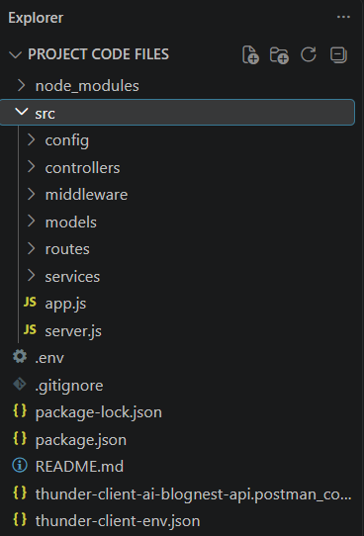
Fig. 5 – Project folder structure in VS Code

Server Setup (npm init)
npm init -y
Folders created inside src/: config, controllers, middleware, models, routes, services.

Install Backend Packages
npm install express mongoose cors dotenv bcryptjs jsonwebtoken express-validator morgan @google/generative-ai axios
npm install --save-dev nodemon

Epic 3: Backend Development

server.js


app.js


AI Service Integration (geminiService.js)
- Purpose: Generates blog content and summarizes text using Google's Gemini model via the @google/generative-ai SDK.
- Request Structure: POST /api/ai/generate-blog → { topic, category? } (Bearer token required); POST /api/ai/summarize → { content }.
- Response Structure: generate-blog returns the created Blog document; summarize returns { summary }.
- Cost Considerations: Each Gemini call consumes API quota. In generate-blog, the Gemini call happens before the database write, so a subsequent validation failure still consumes quota.
- Security Practices: /generate-blog is protected by JWT middleware; inputs are validated with express-validator; the Gemini API key is stored in .env and never exposed to the client.

Epic 4: Database Configuration

DB Connection

Install Mongoose:
npm install mongoose

Mongoose Schema Definitions

1. User Schema (models/User.js)


2. Blog Schema (models/Blog.js)
Fields: title (String, required), content (String, required), category (String, required), author (ObjectId ref User, required), authorName (String, required), with automatic createdAt / updatedAt timestamps.

Epic 5: Project Execution
- Install Postman or Thunder Client (VS Code extension).
- Configure .env with PORT, MONGO_URI, JWT_SECRET, GEMINI_API_KEY, GEMINI_MODEL.
Start the backend server:
npm run dev

API Testing

User Registration
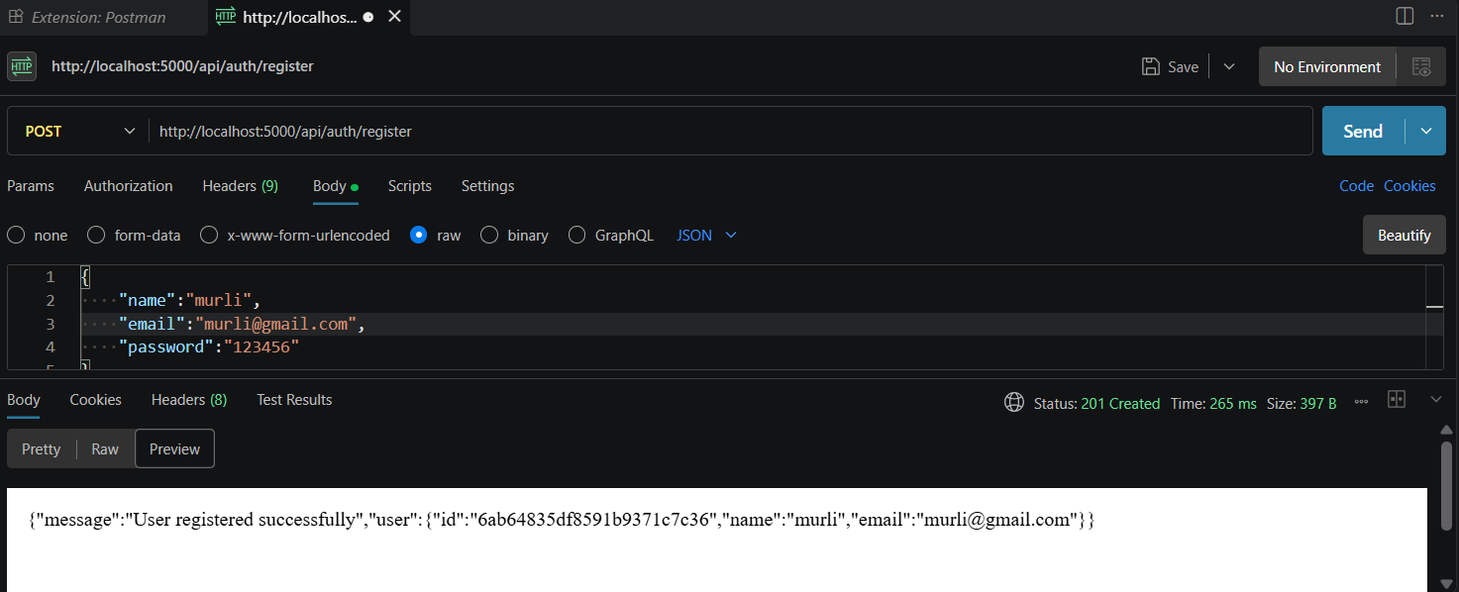

User Login
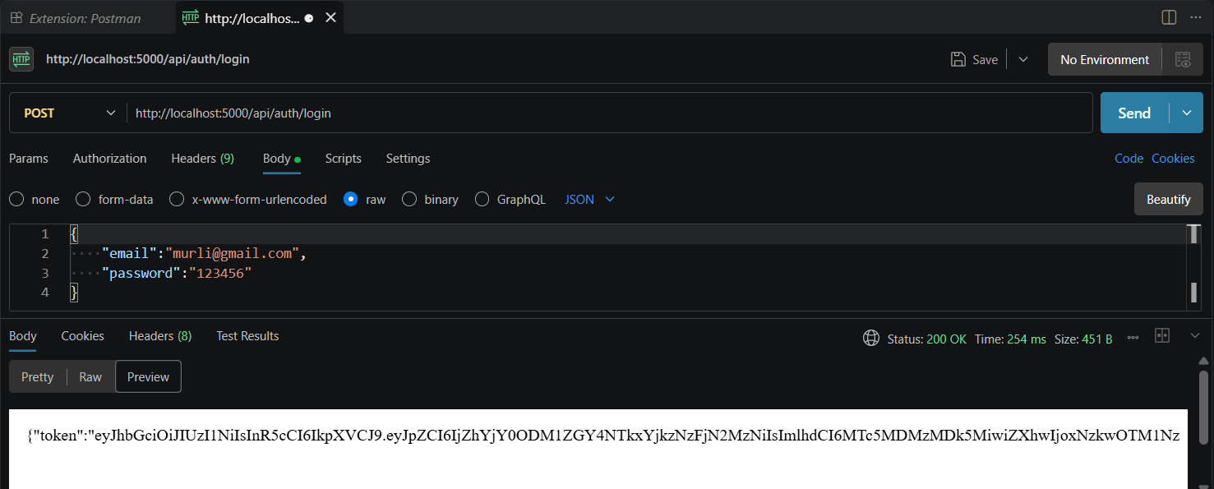

Create Blogs
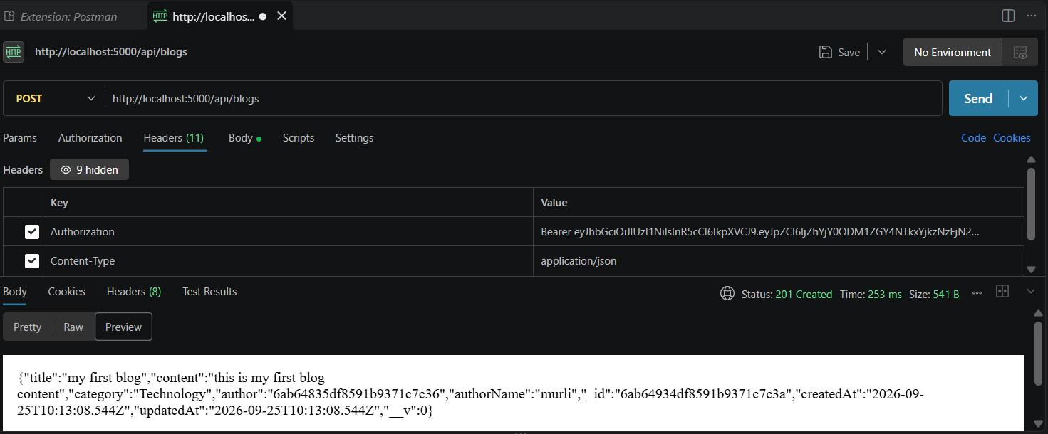

Fetch Blogs
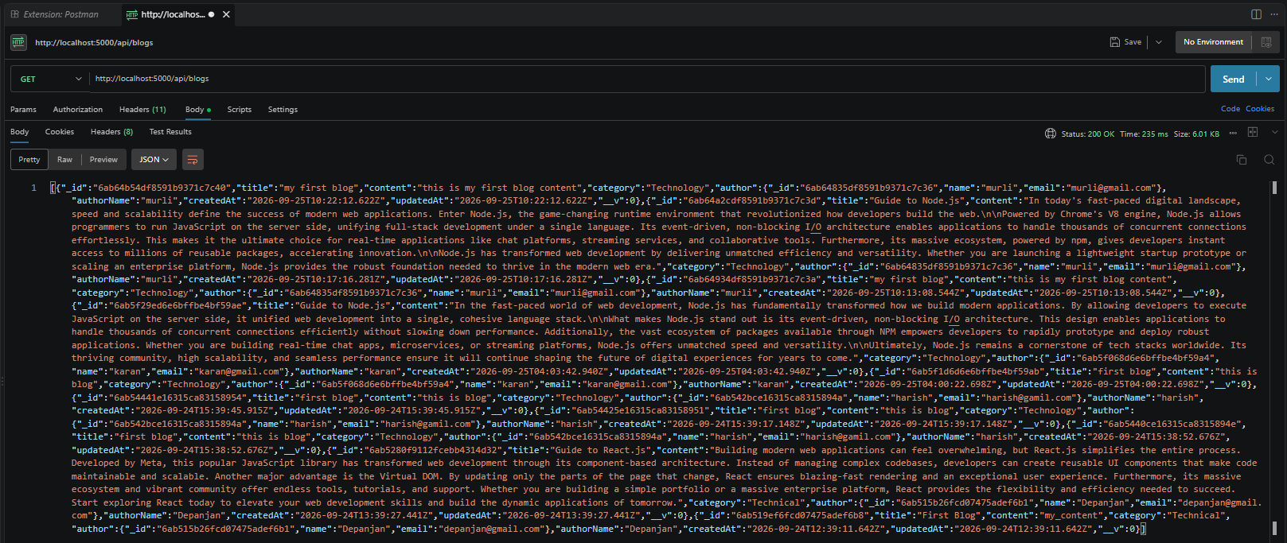

Generate AI Blogs
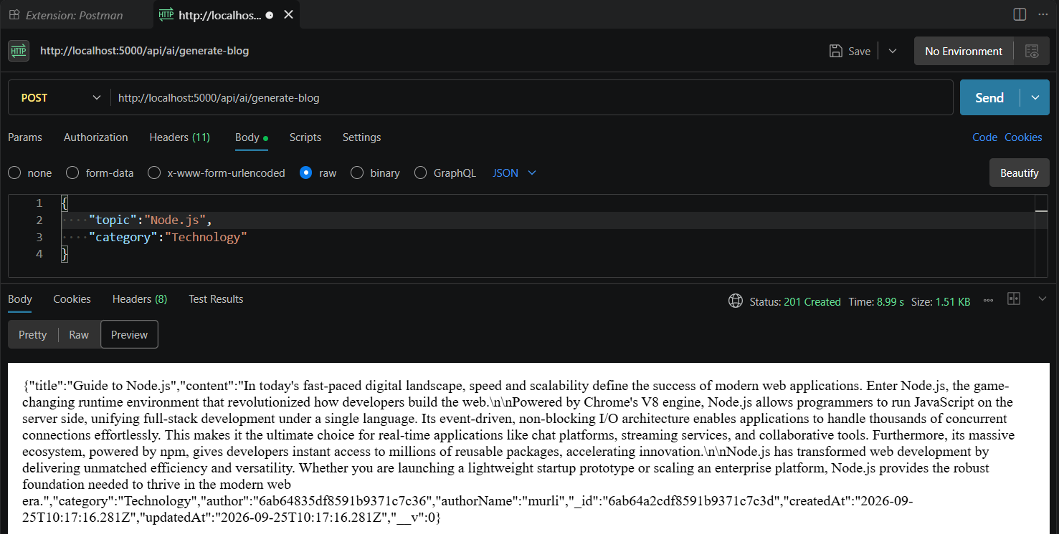

Summarize Blogs
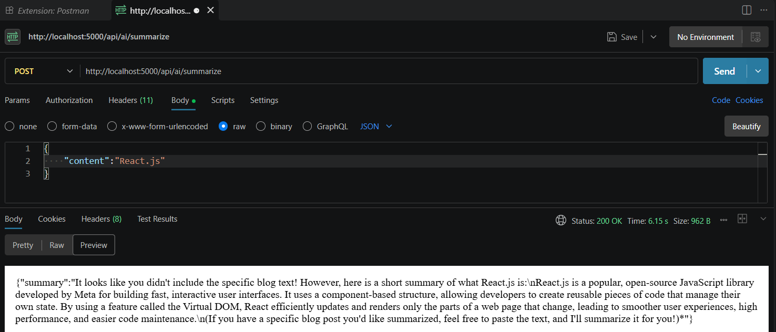

Demo Video
Demo Video: PROJECT VIDEO RECORDINGS

Source Code Drive Link
Code: PROJECT CODE FILES

